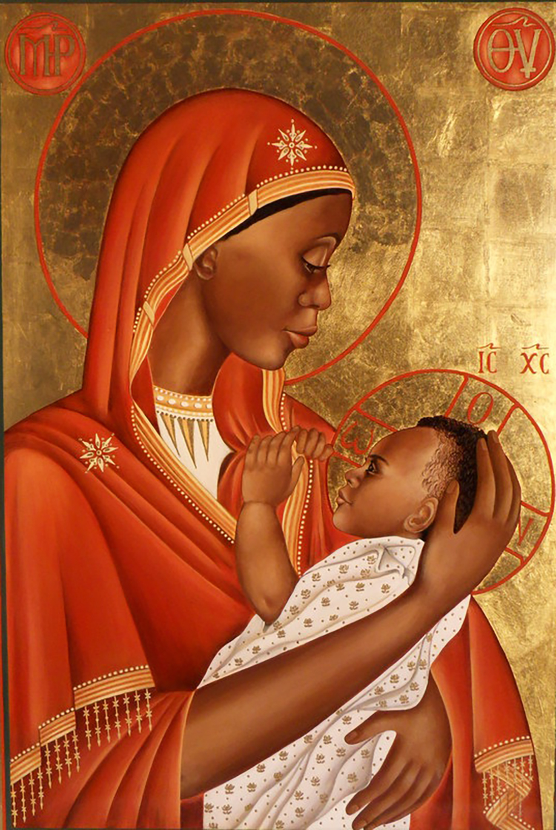
© David Macaire | Facebook | Fair Use
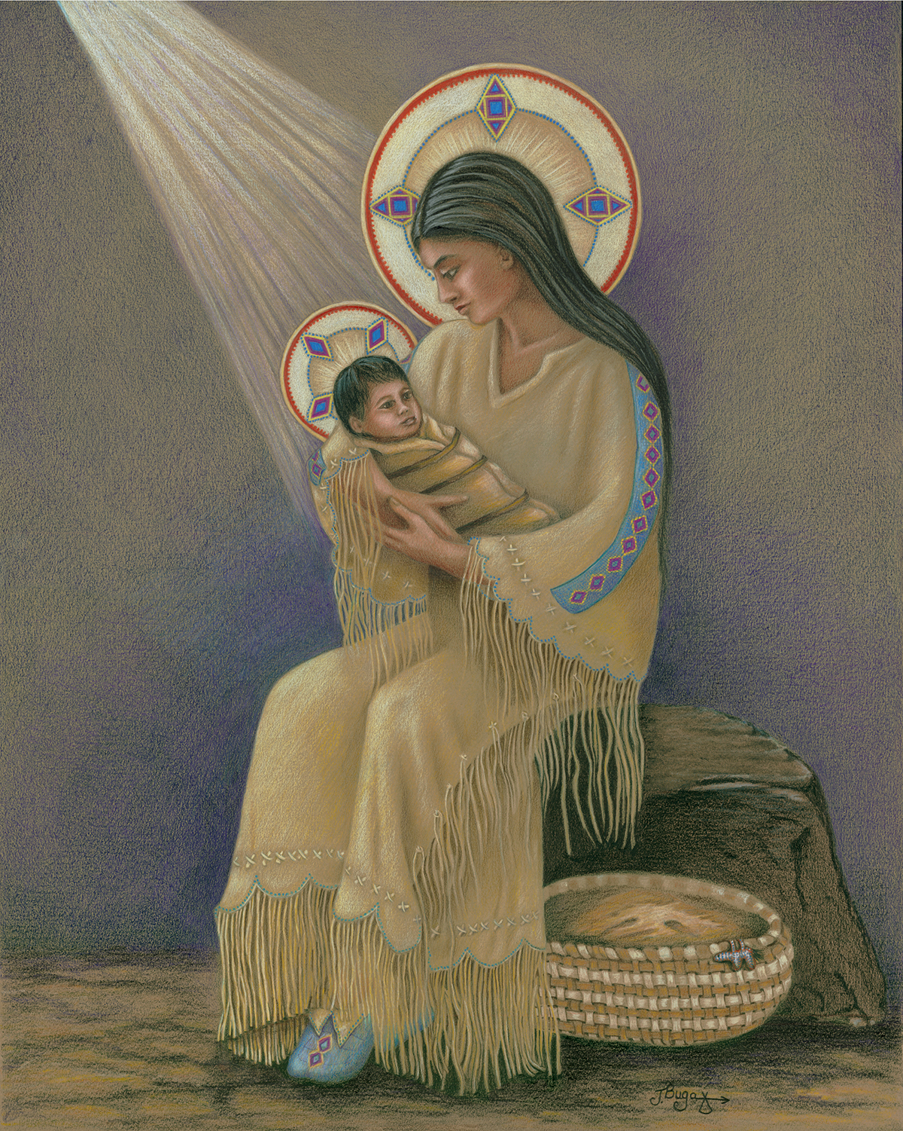
© Courtesy of Joyce Bugaiski

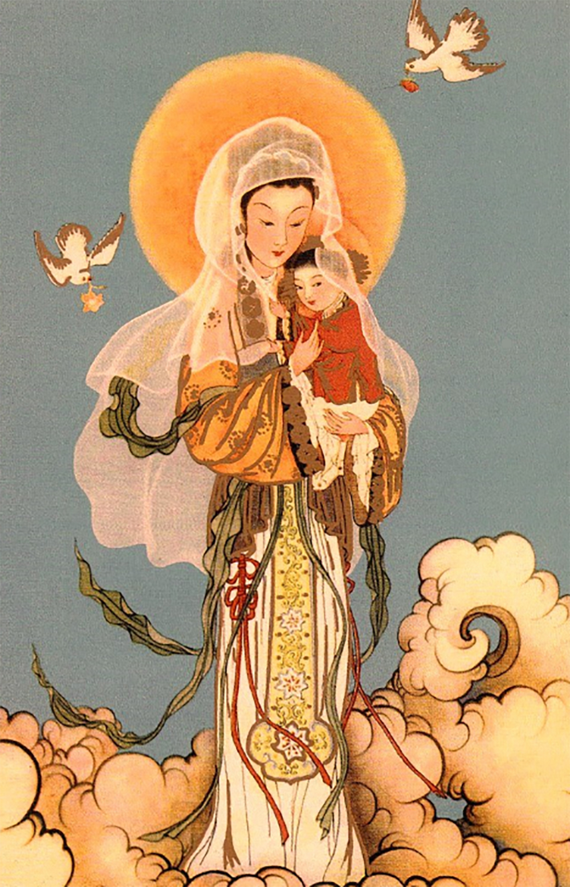
© Philip K | Flickr | Public Domain
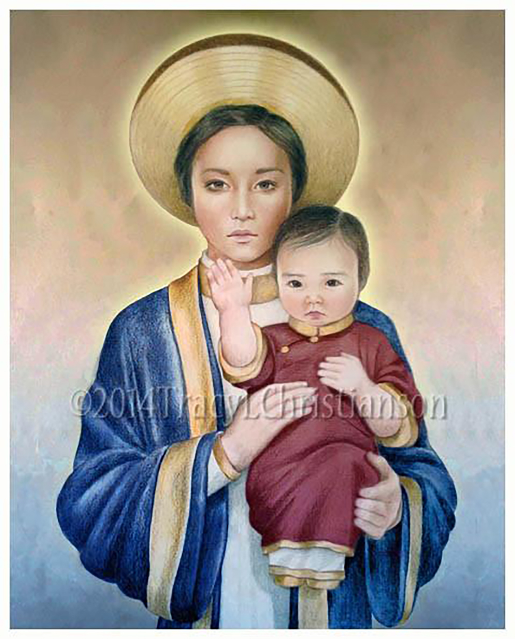
© Courtesy of Tracy L. Christianson. Used with Permission.

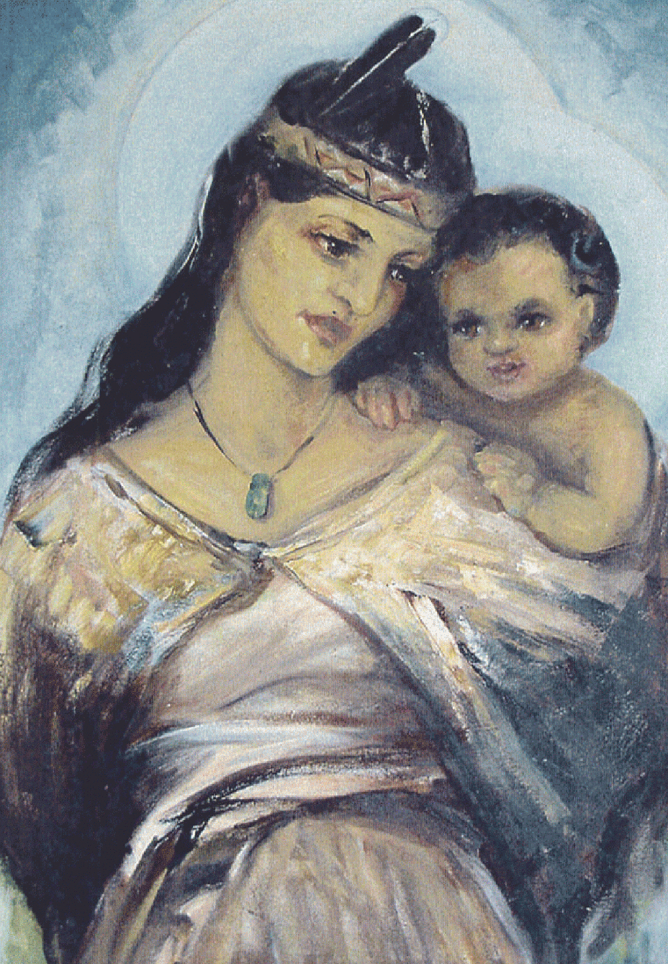
© By Julia Bridget Lynch, ca. 1953-1954. Southern Star Abbey, Kopua, Hawkes Bay. Permission granted by Father Nicholas Verkley OCSO. (Kopua Monastery, HB).
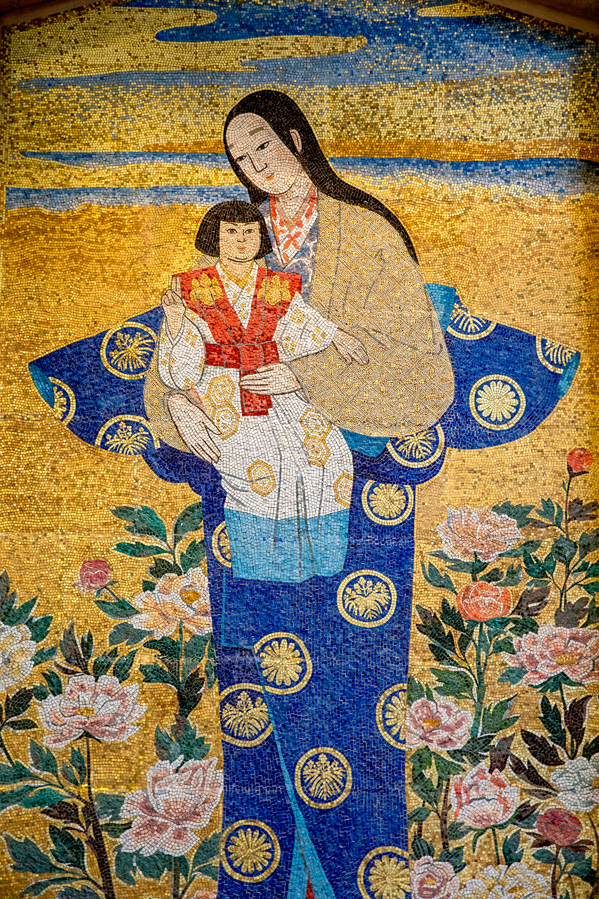
© Philippe Lissac | Godong
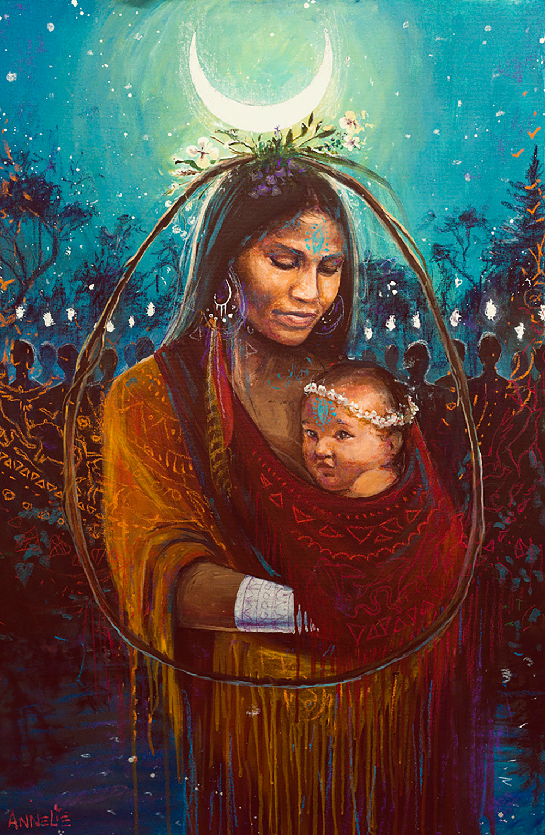© Courtesy of Annelie Solis
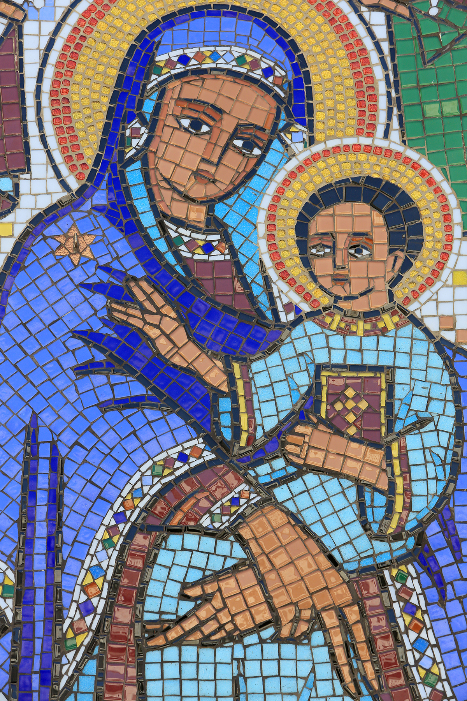
© Catherine Leblanc | Godong
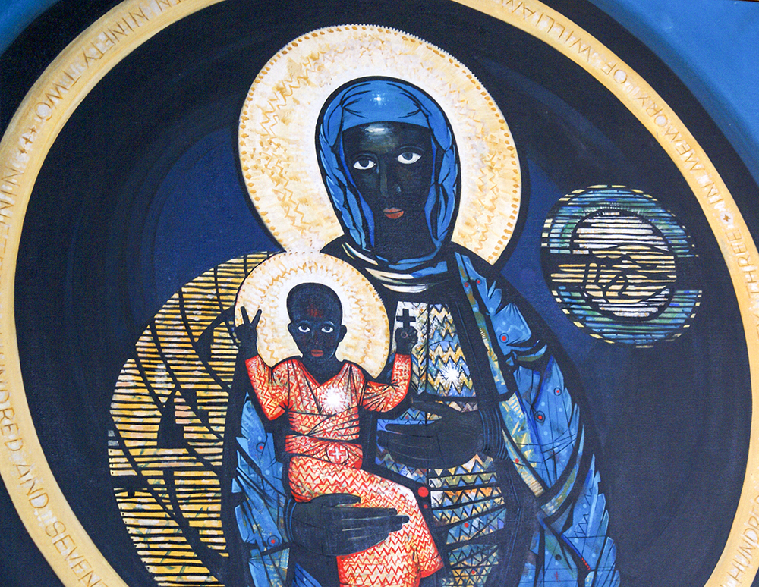
© Justin Hall | Flickr CC BY 2.0

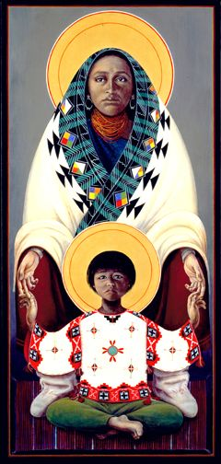
© Karla Solorzano / Pinterest
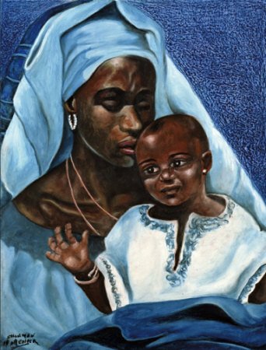
© magickalgraphics.com

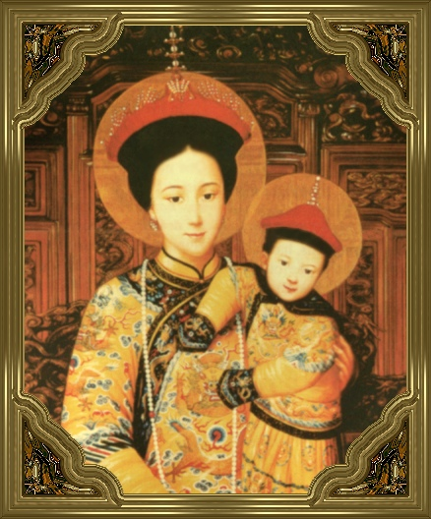
© DR
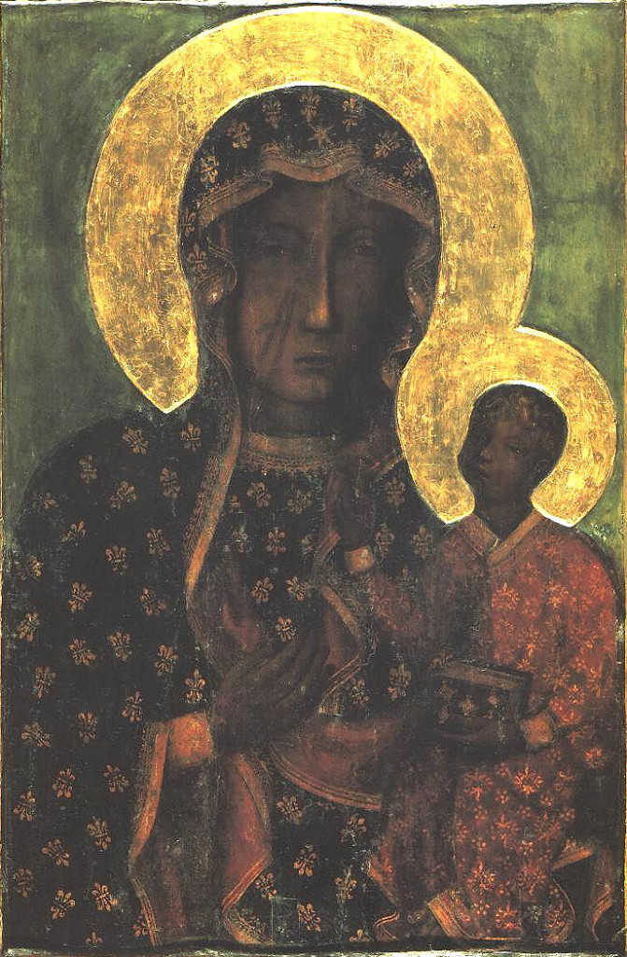
© Public Domain / Wikimedia Commons
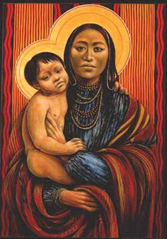
© Karla Solorzano / Pinterest

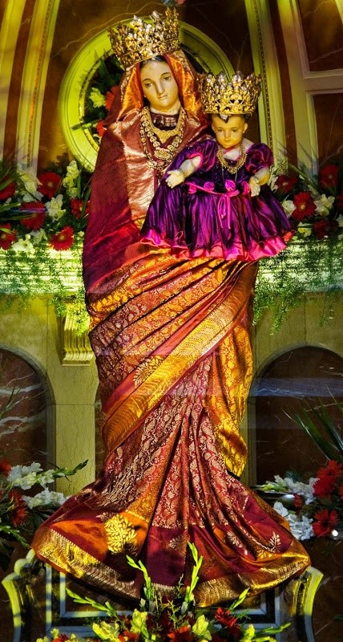
© Her Grace Sacred Art / Pinterest

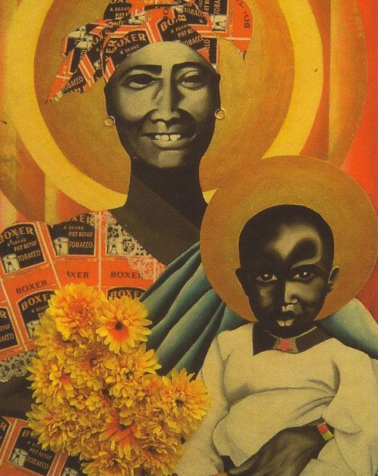
© Onbekend /Pinterest

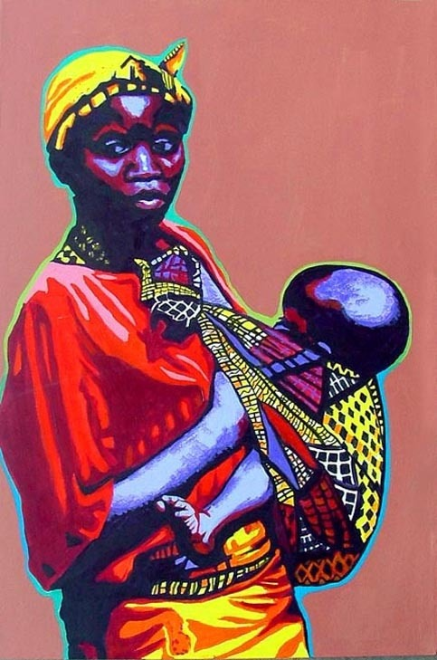
© Onbekend / Pinterest
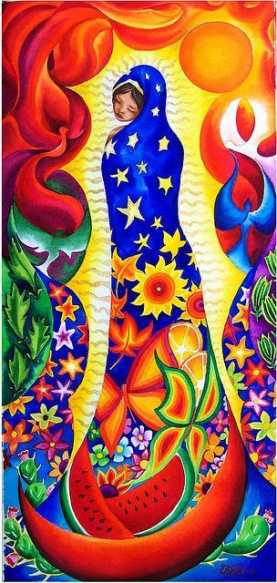
© Adry Del Rodo / Pinterest
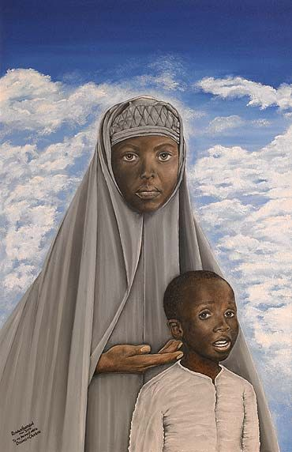
© outlookindia.com / Pinterest

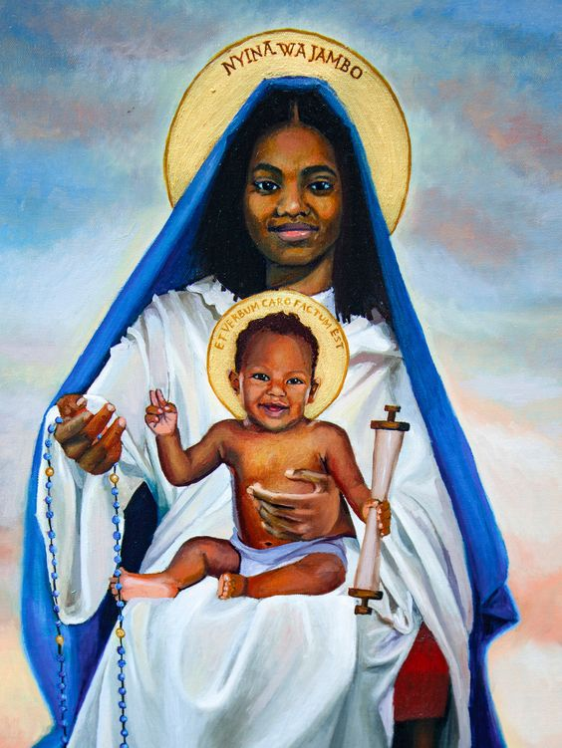
© Onbekend / Pinterest

